**DCCM物流管理基础数据测试说明（PART-1）V1.2**

**2017-12-05**

## Login the system

Please enter the IP address in Chrome Browser.Then input your account, password, and select the language follow below.

IP:<http://192.168.228.188>

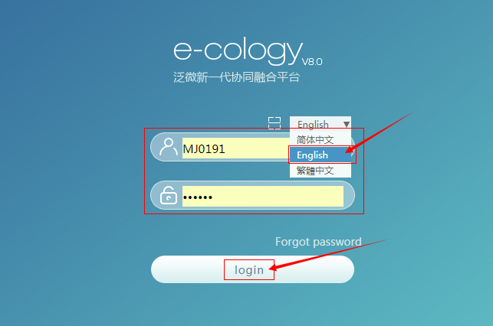

## 基础数据BaseData

### 币种维护单CurrencyMaintain

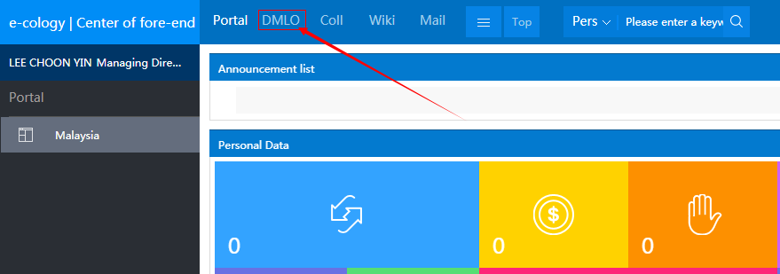

Menu

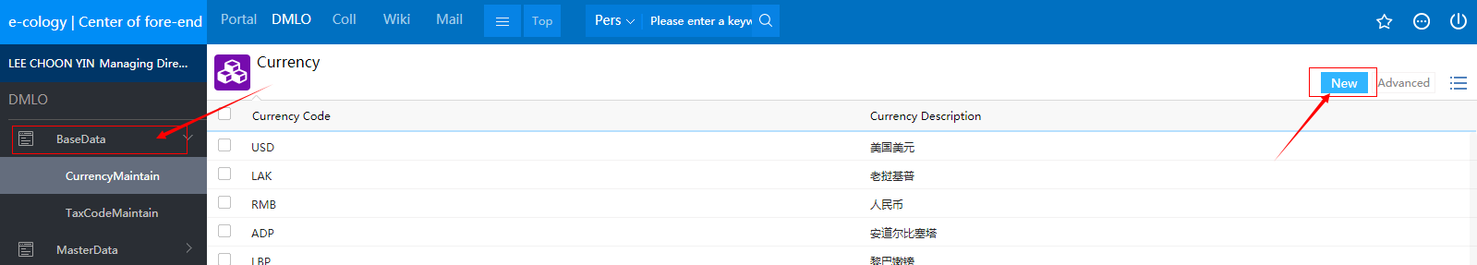

Create , please click “New”, input “Currency Code”、”Currency Description”, and click “Save”

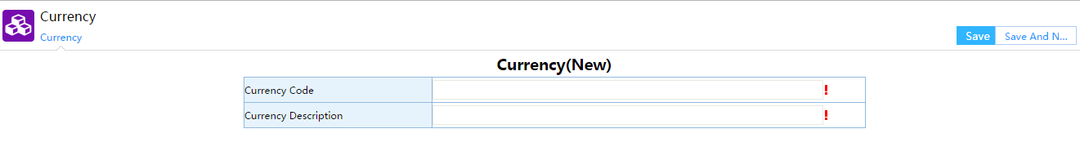

### 税码维护单TaxCodeMaintain

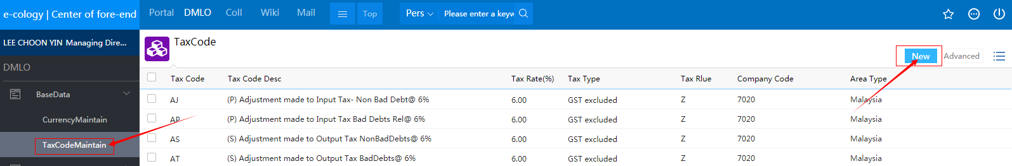

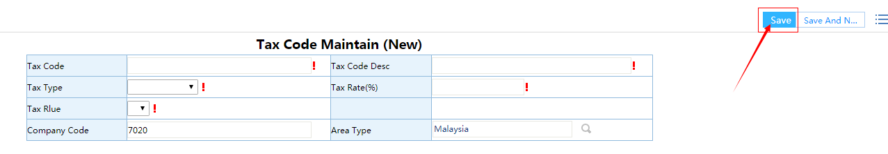

Click the button of ‘New’, enter the view for creating.Then input your data about the Tax Code.Importantly, don’t forget to click the button of ‘Save’.

## 业务主数据MasterData

### 城市与运输线路Trans Area & Citys

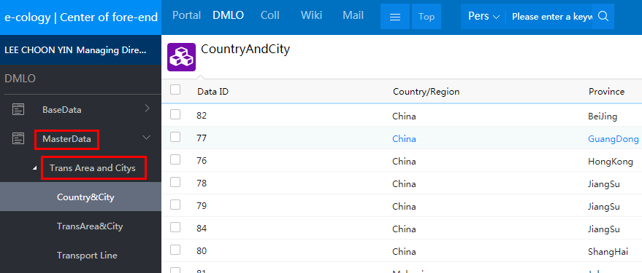

#### 城市基础表Country & City

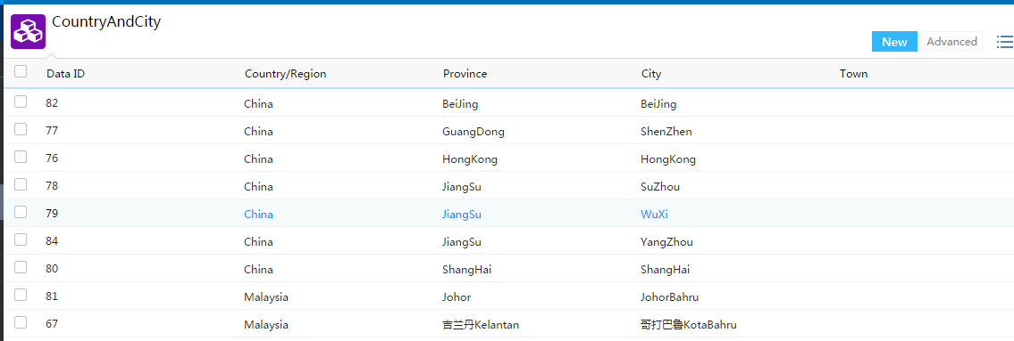

New

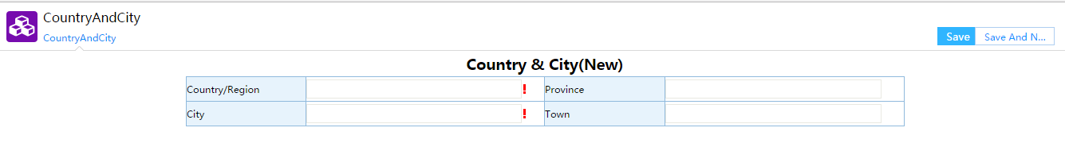

#### 运输城市点TransArea & City

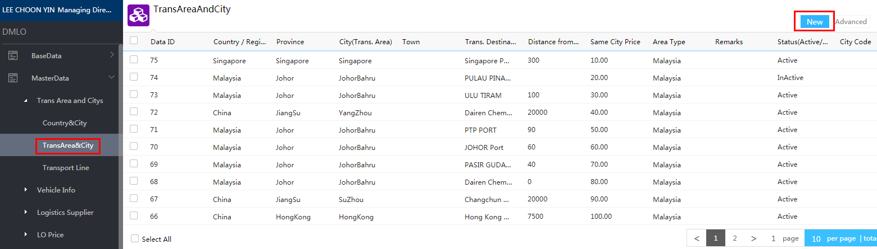

New

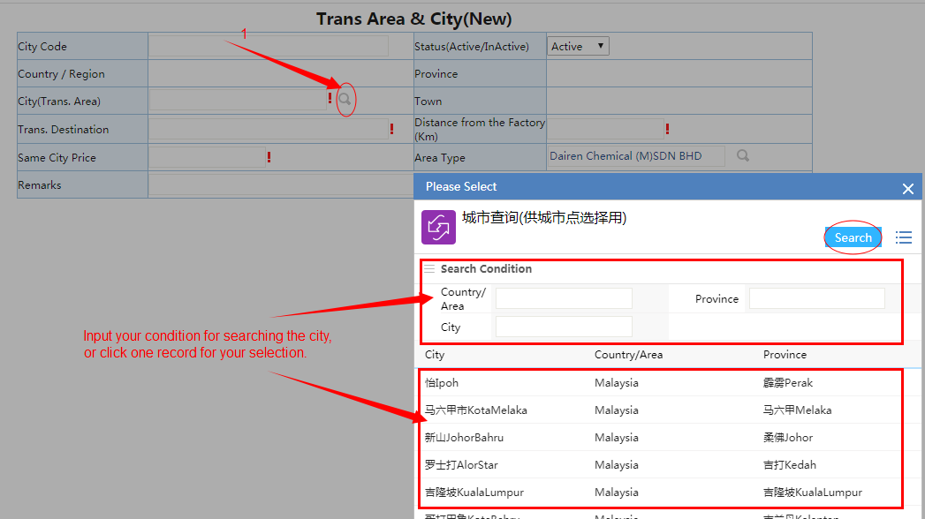

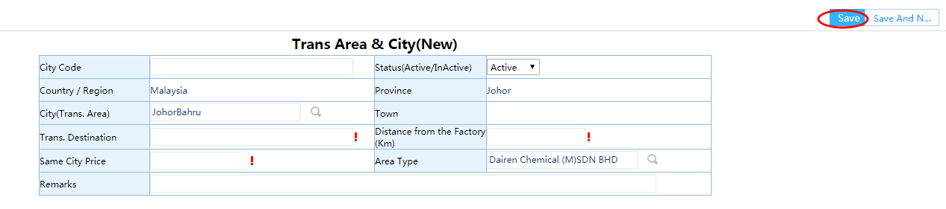

Complete the form item, and Save it.

#### 运输线路Transport Line

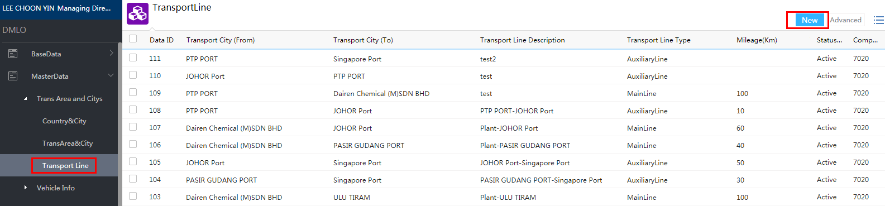

New

Transport City (From) 、Transport City (To) 、Transport Line Description etc

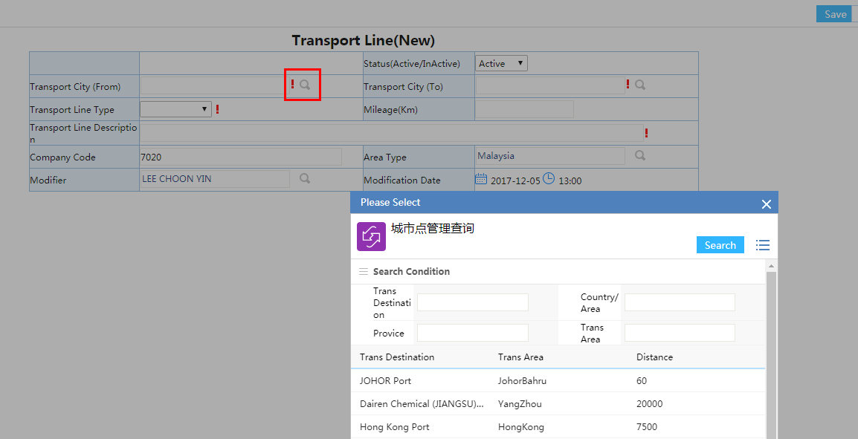

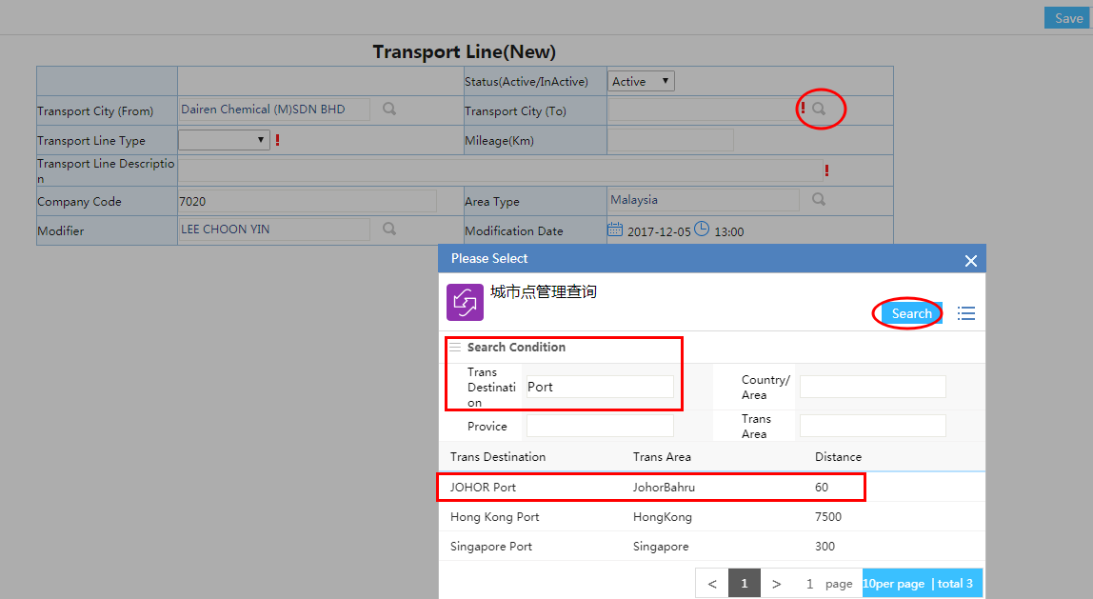

Save

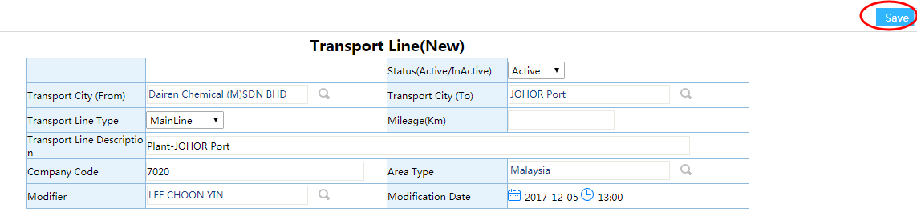

### 车辆管理Vehicle Info

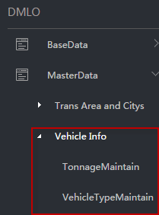

#### 吨位维护单TonnageMaintain

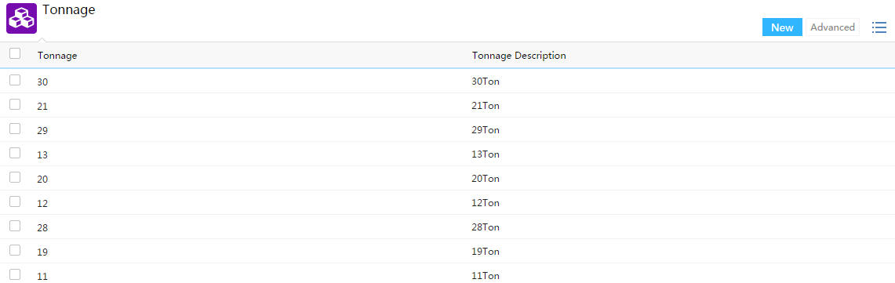

New

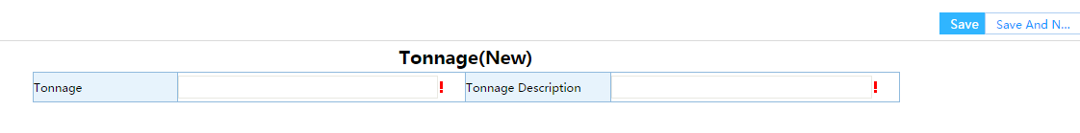

#### 车型维护单VehicleType

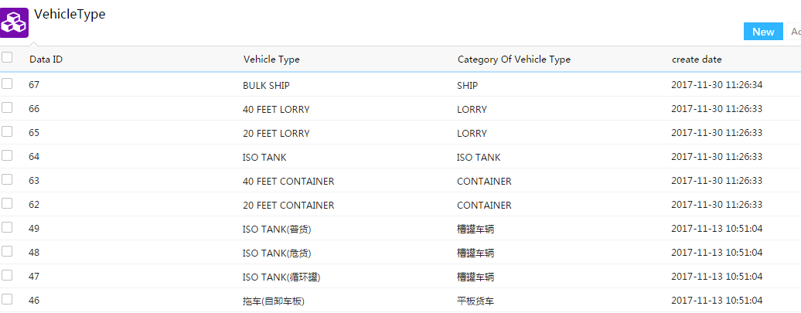

New

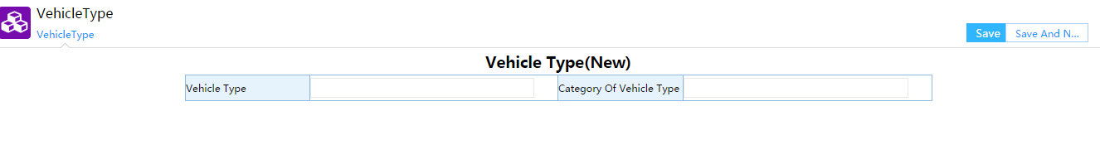

### 物流供应商Logistics Supplier

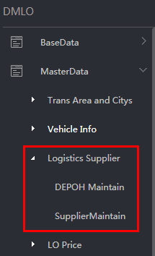

#### 货柜厂维护DEPOH Maintain

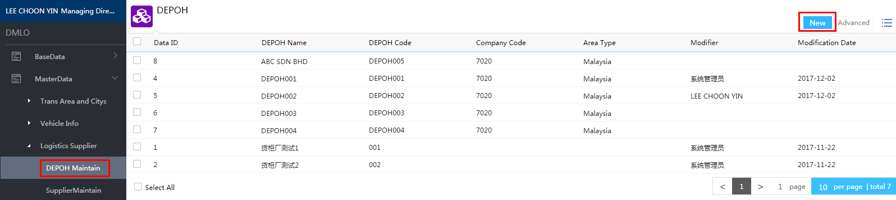

New

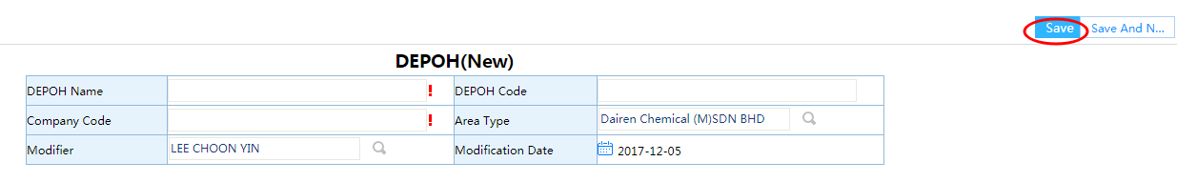

#### 供应商维护SupplierMaintain

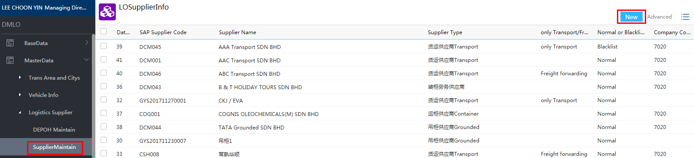

New

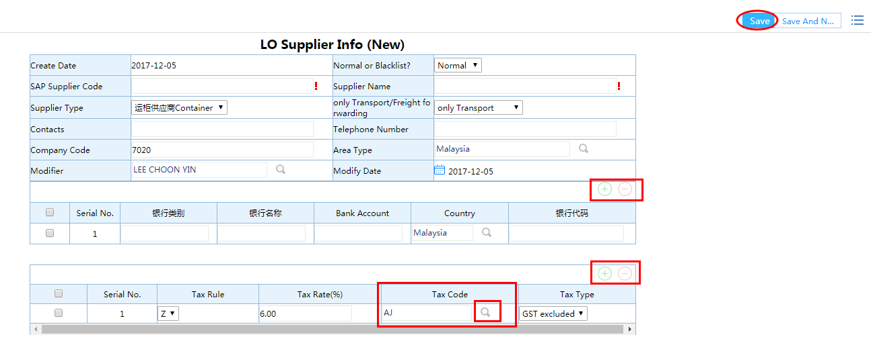

Here, selecting the Tax Code will make Tax Rate and Tax Type pop out by this linkage.

### 物流价格管理LO Price

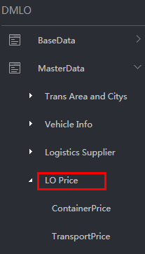

#### 货柜价格Container Price

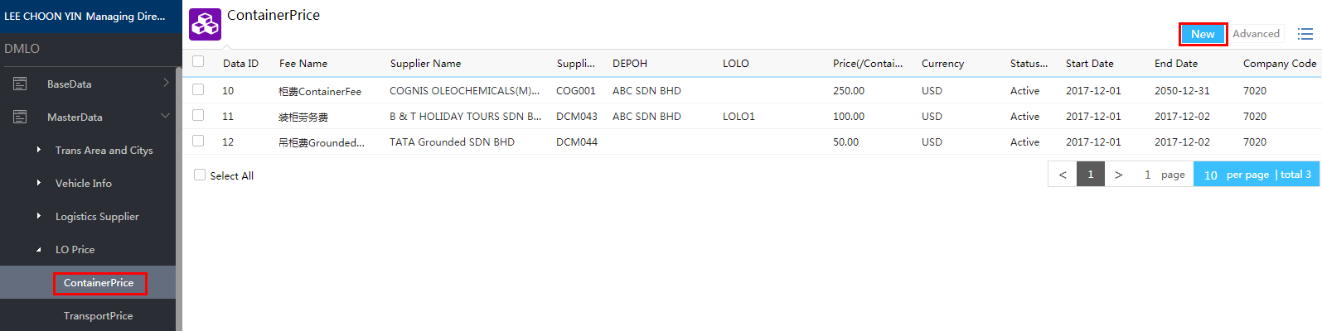

New

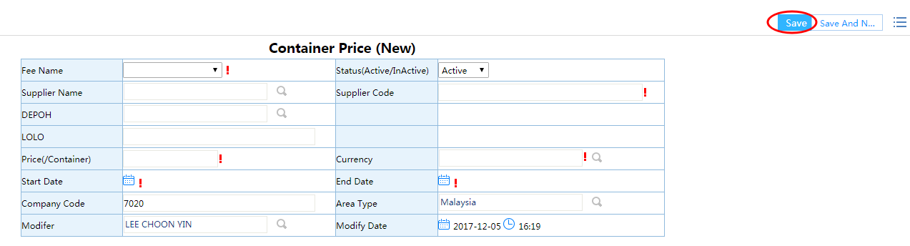

#### 运输价格Transport Price

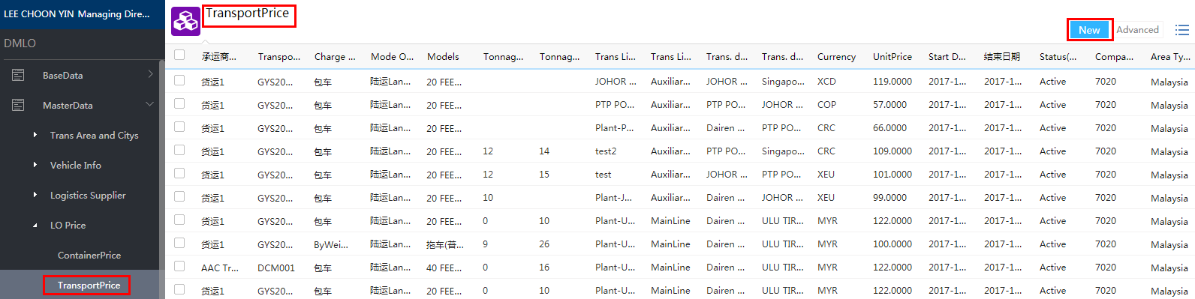

New

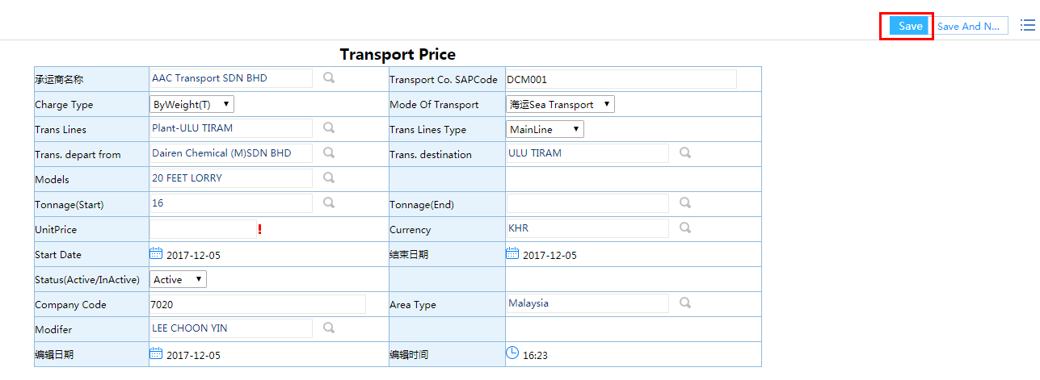

### 权限维护Permissions

### SAP基础数据维护SAPBase

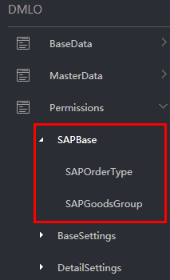

#### SAP订单类型SAPOrderType

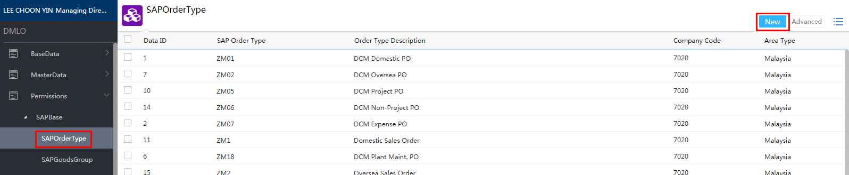

New

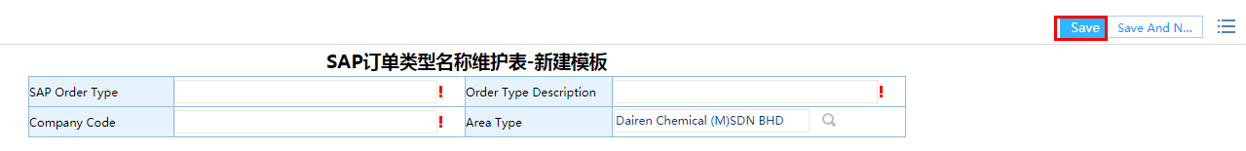

#### SAP产品组SAPGoodsGroup

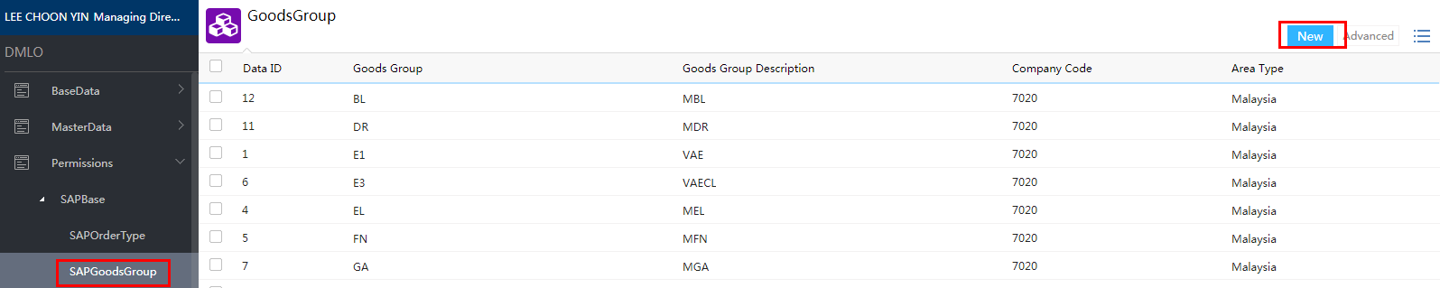

New

Complete the form and Save it.

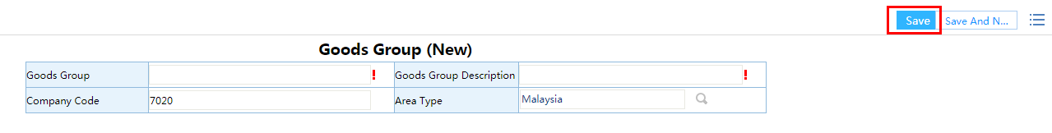

### 基础设置BaseSettings

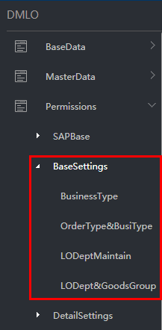

#### 进出厂类型BusinessType

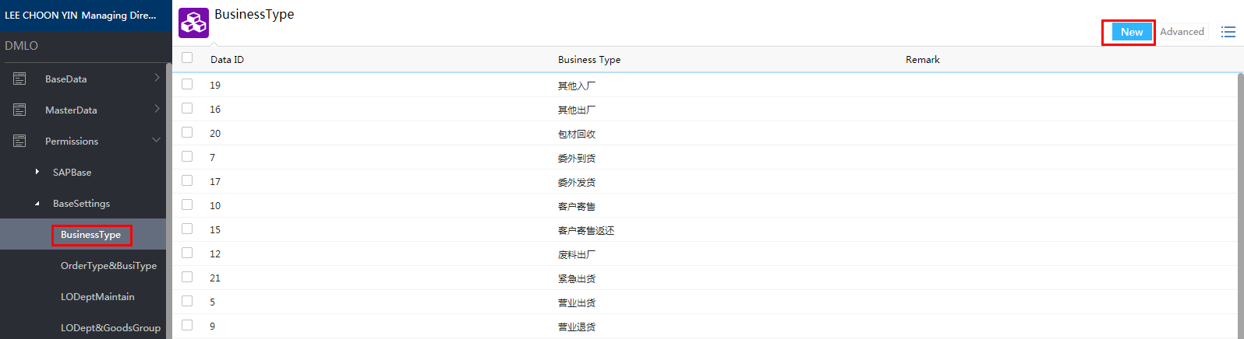

New

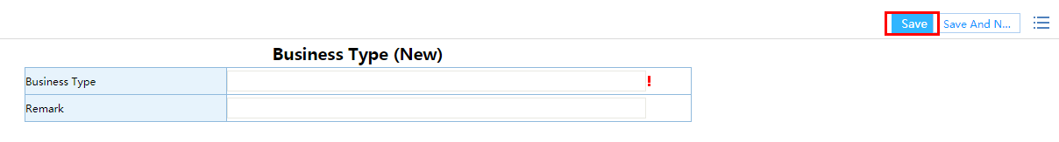

#### 订单类型和进出厂类型对应维护表OrderType&BusiType

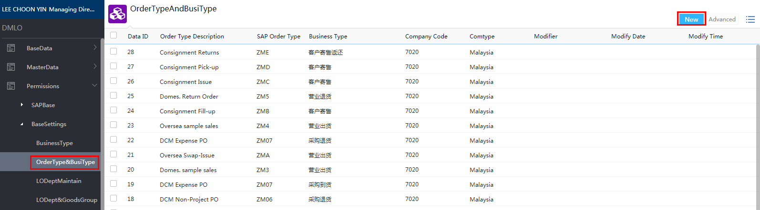

New

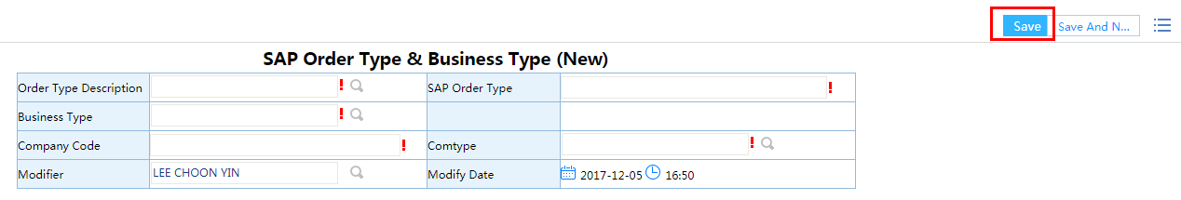

#### 物流部门维护LODeptMaintain

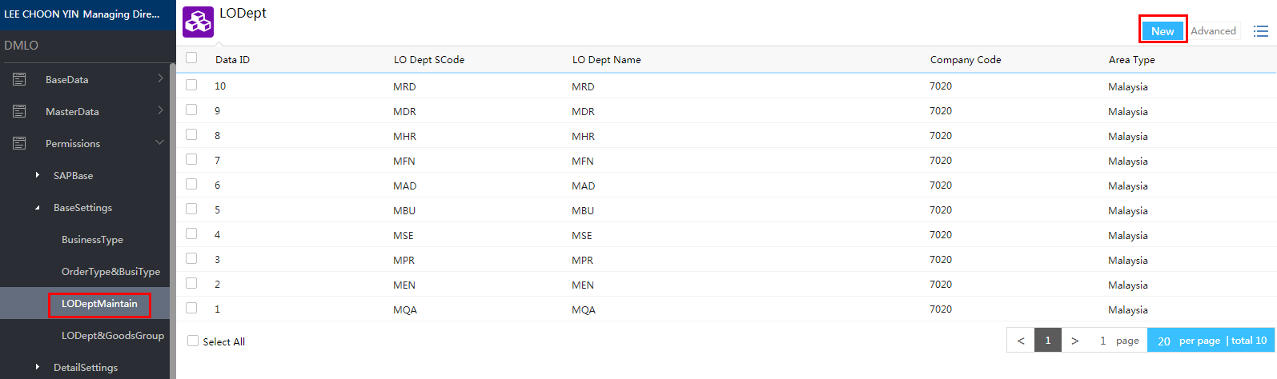

New

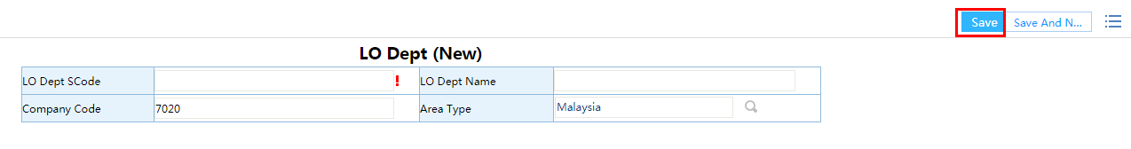

#### 物流部门与产品组对应维护表LODeptAndGoodsGroup

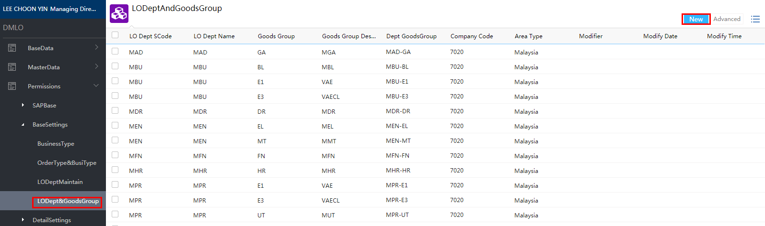

New

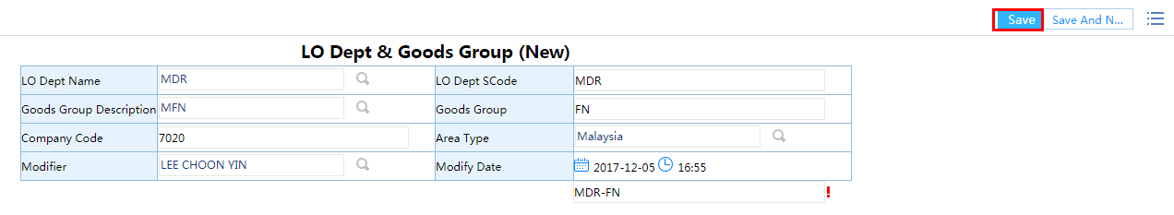

### 明细设置DetailSettings

#### 物流成本中心LOCostCenter

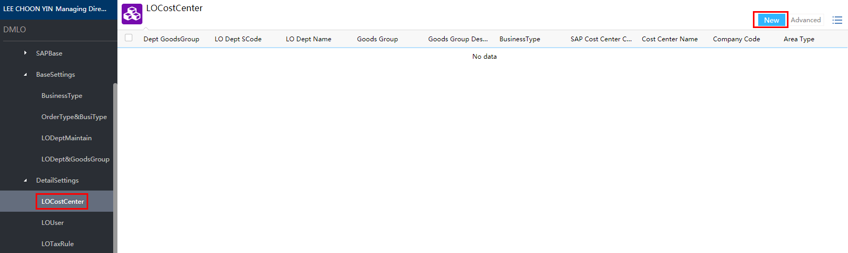

New

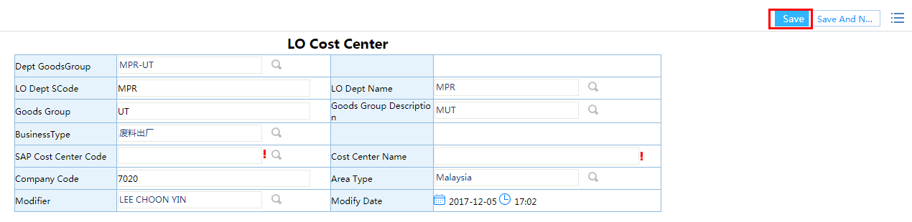

#### 维护者LOUser

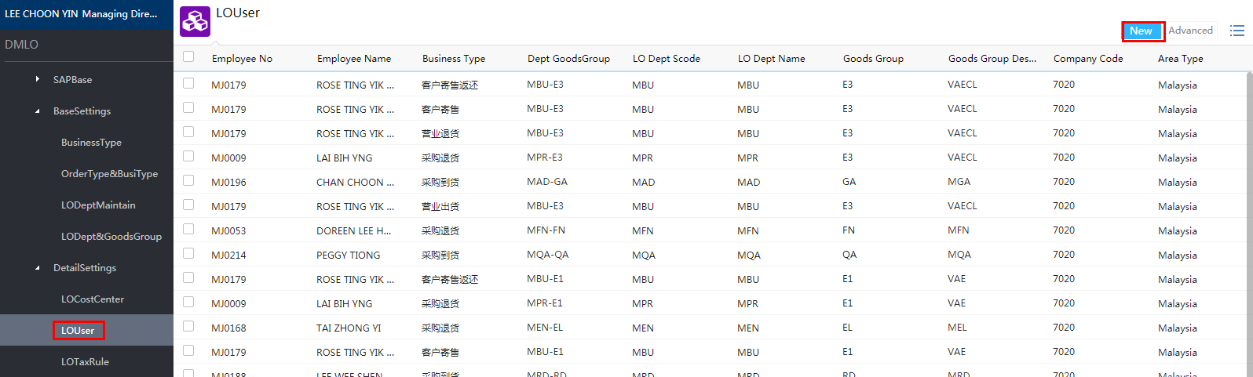

New

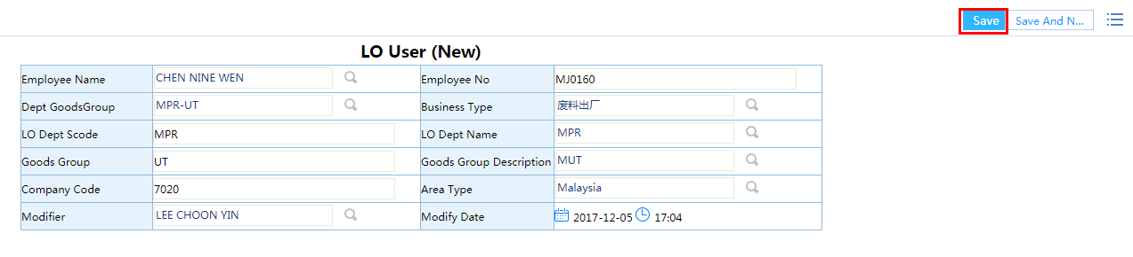

#### 税则维护LOTaxRule

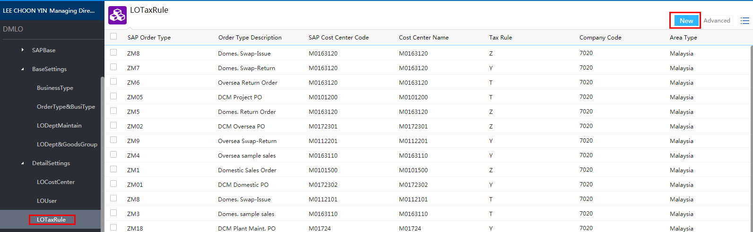

New

